**Kitchen Story.**

Project 2

DESCRIPTION

**Project objective:**

Kitchen Story is an e-commerce portal that lets people shop  basic food items on their website. The website needs to have the following features:

* A search form in the home page to allow entry of the food items to be purchased by the customer.
* Based on item details entered, it will show available food items with  price.
* Once a person selects an item to purchase, they will be redirected to the list of available items. In the next page, they are shown the complete breakout of the order and details of the payment to be made in the payment gateway. When payment is done, they are shown a confirmation page with details of the order.

**For the above features to work, there will be an admin backend with the following features:**

* Admin login page where admin can change password after login if he wants to
* A master list of food items available for purchase
* A functionality to add or remove food items

The application enables user to do operations as follows :-

* A search form in the home page to allow entry of the food items to be purchased by the customer.
* Based on item details entered, it will show available food items with  price.
* Once a person selects an item to purchase, they will be redirected to the list of available items. In the next page, they are shown the complete breakout of the order and details of the payment to be made in the payment gateway. When payment is done, they are shown a confirmation page with details of the order.

**Technologies used :-**

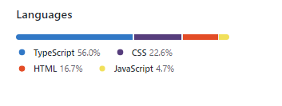

Sequence of steps :-

## **A step-by-step guide to creating your first Angular Project**

### **Step 1**

Create a folder for your application in the desired location on your system and open it on VSCode. Open a new terminal and type in the following command to create your app folder.

ng new <project_name>

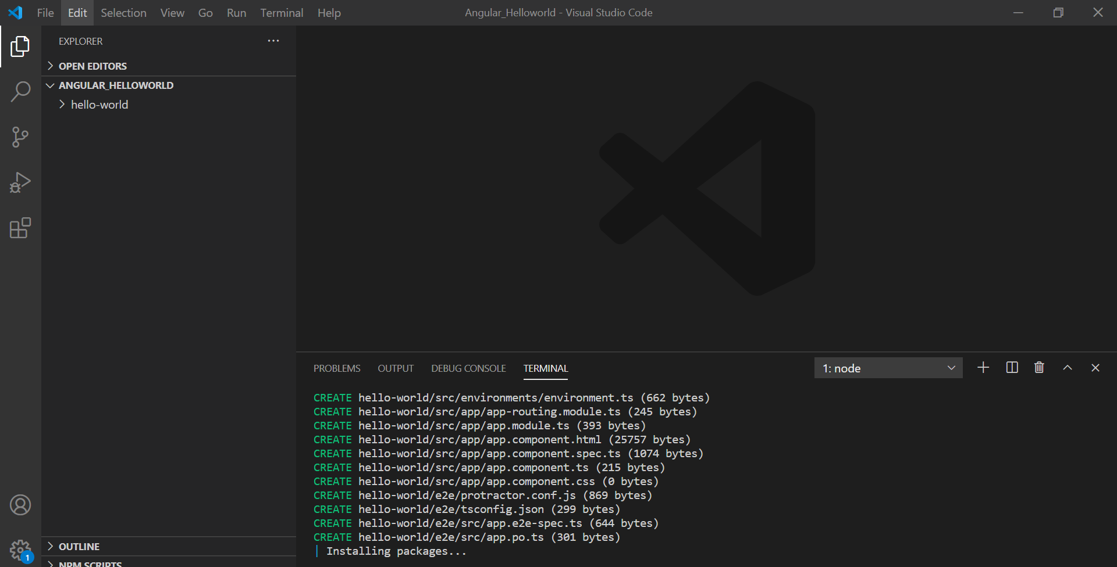

When the command is run, Angular creates a skeleton application under the folder. It also includes a bunch of files and other important necessities for the application.

### **Step 2**

To run the application, change the directory to the folder created, and use the ng command.

cd <project_name>

ng serve

Once run, open your browser and navigate to localhost:4200. If another application is running on that address, you can simply run the command.  
ng serve --port

It will generate a port for you to navigate to. Typically, the browser looks something like this:

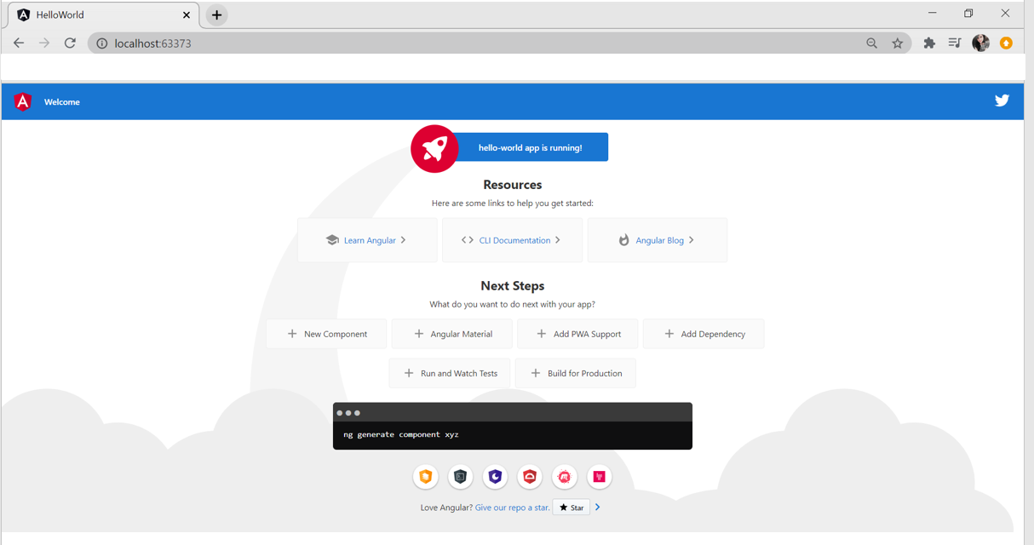

### **Step 3**

Install Bootstrap and JQuery into your application. To do that, run the following commands in the terminal.

npm install bootstrap

npm install jquery

### **Step 4**

Add the relative paths to the JavaScript files in the script array of the angular.json file.

"scripts": [

              "node_modules/bootstrap/dist/js/bootstrap.min.js",

              "node_modules/jquery/dist/jquery.min.js",

              "node_modules/jquery-easing/jquery.easing.min.js",

              "js/sb-admin-2.min.js",

              "vendor/chart.js/Chart.min.js",

              "js/demo/chart-area-demo.js",

              "js/demo/chart-pie-demo.js",

              "node_modules/bootstrap/dist/js/bootstrap.bundle.js"

            ]

Also, add the CSS file in the styles array of the angular.json file.

"styles": [

"src/styles.css","node_modules/bootstrap/dist/css/bootstrap.min.css" ],

#### **Full Stack Java Developer Course**

In Partnership with HIRIST and HackerEarth[EXPLORE COURSE](https://www.simplilearn.com/java-full-stack-developer-certification-training-course?source=GhPreviewCTABanner)

Full Stack Java Developer Course

### **Step 5**

Add the following URLs in the index.html file.

<!doctype html>

<html lang="en">

<head>

  <meta charset="utf-8">

  <title>Project</title>

  <base href="/">

  <meta name="viewport" content="width=device-width, initial-scale=1">

  <link rel="icon" type="image/x-icon" href="">

  <link href="css/styles.css" rel="stylesheet" />

  <link rel="stylesheet" href="https://cdnjs.cloudflare.com/ajax/libs/font-awesome/4.7.0/css/font-awesome.min.css">

  <script src="https://cdnjs.cloudflare.com/ajax/libs/font-awesome/5.15.1/js/all.min.js" crossorigin="anonymous"></script>

  <script src="https://ajax.googleapis.com/ajax/libs/jquery/3.3.1/jquery.min.js"></script>

<script src="https://getbootstrap.com/docs/4.0/dist/js/bootstrap.min.js"></script>

<script src="node_modules/chart.js/Chart.min.js"></script>

<script src="node_modules/angular-chart.js/dist/angular-chart.min.js"></script>

</head>

<body>

  <app-root></app-root>

</body>

</html>

Now that the initial setup is done, go ahead and create a component. We have created the navbar components. However, it includes the code for all parts of the UI.

<router-outlet></router-outlet>

<body class="sb-nav-fixed">

    <nav class="sb-topnav navbar navbar-expand navbar-dark bg-dark">

        <a class="navbar-brand" href="index.html"><img src="assets/Logo.png" width="80%" height="120%" style="padding-top: 10px;"></a>

        <button class="btn btn-link btn-sm order-1 order-lg-0" id="sidebarToggle" href="#"><i class="fas fa-bars"></i></button>

        <!-- Navbar Search-->

        <form class="d-none d-md-inline-block form-inline ml-auto mr-0 mr-md-3 my-2 my-md-0">

            <div class="input-group">

                <input class="form-control" type="text" placeholder="Search for..." aria-label="Search" aria-describedby="basic-addon2" />

                <div class="input-group-append">

                    <button class="btn btn-primary" type="button"><i class="fas fa-search"></i></button>

                </div>

            </div>

        </form>

        <!-- Navbar-->

        <ul class="navbar-nav ml-auto ml-md-0">

            <li class="nav-item dropdown">

                <a class="nav-link dropdown-toggle" id="userDropdown" href="#" role="button" data-toggle="dropdown" aria-haspopup="true" aria-expanded="false"><img src="assets/id.jpg"  style="border-radius: 50%;" width="50px" height="50px"></a>

                <div class="dropdown-menu dropdown-menu-right" aria-labelledby="userDropdown">

                    <a class="dropdown-item" href="#">Settings</a>

                    <a class="dropdown-item" href="#">Activity Log</a>

                    <div class="dropdown-divider"></div>

                    <a class="dropdown-item" href="#" routerLink = "/login" routerLinkActive= "active">Logout</a>

                </div>

            </li>

        </ul>

    </nav>

    <div id="layoutSidenav">

        <div id="layoutSidenav_nav">

            <nav class="sb-sidenav accordion sb-sidenav-dark" id="sidenavAccordion">

                <div class="sb-sidenav-menu">

                    <div class="nav">

                        <div class="sb-sidenav-menu-heading">Core</div>

                        <a class="nav-link" href="index.html">

                            <div class="sb-nav-link-icon"><i class="fas fa-tachometer-alt"></i></div>

                            Dashboard

                        </a>

                        <div class="sb-sidenav-menu-heading">Interface</div>

                        <a class="nav-link collapsed" href="#" data-toggle="collapse" data-target="#collapseLayouts" aria-expanded="false" aria-controls="collapseLayouts">

                            <div class="sb-nav-link-icon"><i class="fas fa-home"></i></div>

                            Home

                            <div class="sb-sidenav-collapse-arrow"><i class="fas fa-angle-down"></i></div>

                        </a>

                        <div class="collapse" id="collapseLayouts" aria-labelledby="headingOne" data-parent="#sidenavAccordion">

                            <nav class="sb-sidenav-menu-nested nav">

                                <a class="nav-link" href="#" routerLink = "/static">Profile</a>

                            </nav>

                        </div>

                        <a class="nav-link collapsed" href="#" data-toggle="collapse" data-target="#collapsePages" aria-expanded="false" aria-controls="collapsePages">

                            <div class="sb-nav-link-icon"><i class="fas fa-cog"></i></div>

                            Settings

                            <div class="sb-sidenav-collapse-arrow"><i class="fas fa-angle-down"></i></div>

                        </a>

                        <div class="collapse" id="collapsePages" aria-labelledby="headingTwo" data-parent="#sidenavAccordion">

                            <nav class="sb-sidenav-menu-nested nav accordion" id="sidenavAccordionPages">

                                <a class="nav-link collapsed" href="#" data-toggle="collapse" data-target="#pagesCollapseAuth" aria-expanded="false" aria-controls="pagesCollapseAuth">

                                    Account Settings

                                    <div class="sb-sidenav-collapse-arrow"><i class="fas fa-angle-down"></i></div>

                                </a>

                                <div class="collapse" id="pagesCollapseAuth" aria-labelledby="headingOne" data-parent="#sidenavAccordionPages">

                                    <nav class="sb-sidenav-menu-nested nav">

                                        <a class="nav-link" href="#" routerLink = "/login" routerLinkActive = "active" >Login</a>

                                        <a class="nav-link" href="#" routerLink = "/register" routerLinkActive = "active" >Register</a>

                                        <a class="nav-link" href="#" routerLink = "/changepassword" routerLinkActive = "active">Change Password</a>

                                    </nav>

                                </div>

                                <a class="nav-link collapsed" href="#" data-toggle="collapse" data-target="#pagesCollapseError" aria-expanded="false" aria-controls="pagesCollapseError">

                                    Activity

                                    <div class="sb-sidenav-collapse-arrow"><i class="fas fa-angle-down"></i></div>

                                </a>

                                <div class="collapse" id="pagesCollapseError" aria-labelledby="headingOne" data-parent="#sidenavAccordionPages">

                                    <nav class="sb-sidenav-menu-nested nav">

                                        <a class="nav-link" href="401.html">401 Page</a>

                                        <a class="nav-link" href="404.html">404 Page</a>

                                        <a class="nav-link" href="500.html">500 Page</a>

                                    </nav>

                                </div>

                            </nav>

                        </div>

                        <a class="nav-link collapsed" href="#">

                            <div class="sb-nav-link-icon"><i class="fas fa-business-time"></i></div>

                            Attendance

                        </a>

                        <a class="nav-link collapsed" href="#">

                            <div class="sb-nav-link-icon"><i class="fas fa-money-check-alt"></i></div>

                            Payroll

                        </a>

                        <a class="nav-link collapsed" href="#">

                            <div class="sb-nav-link-icon"><i class="fas fa-plane"></i></div>

                            Travel Expenses

                        </a>

                        <a class="nav-link collapsed" href="#">

                            <div class="sb-nav-link-icon"><i class="fas fa-user-friends"></i></div>

                            Confirmation

                        </a>

                        <a class="nav-link collapsed" href="#">

                            <div class="sb-nav-link-icon"><i class="fas fa-cloud-download-alt"></i></div>

                            Downloads

                        </a>

                    </div>

                </div>

                <div class="sb-sidenav-footer">

                    <div class="small">Logged in as:</div>

                    Admin

                </div>

            </nav>

        </div>

        <div id="layoutSidenav_content">

            <main>

                <div class="container-fluid">

                    <h1 class="mt-4">Kate Adams</h1>

                    <ol class="breadcrumb mb-4">

                        <li class="breadcrumb-item active">Dashboard</li>

                    </ol>

                    <div class="row">

                        <div class="col-xl-3 col-md-6">

                            <div class="card bg-primary text-white mb-4">

                                <div class="card-body">Birthdays</div>

                                <div class="card-footer d-flex align-items-center justify-content-between">

                                    <a class="small text-white stretched-link" href="#">View Details</a>

                                    <div class="small text-white"><i class="fas fa-angle-right"></i></div>

                                </div>

                            </div>

                        </div>

                        <div class="col-xl-3 col-md-6">

                            <div class="card bg-warning text-white mb-4">

                                <div class="card-body">My Holidays</div>

                                <div class="card-footer d-flex align-items-center justify-content-between">

                                    <a class="small text-white stretched-link" href="#">View Details</a>

                                    <div class="small text-white"><i class="fas fa-angle-right"></i></div>

                                </div>

                            </div>

                        </div>

                        <div class="col-xl-3 col-md-6">

                            <div class="card bg-success text-white mb-4">

                                <div class="card-body">Company Anouncement</div>

                                <div class="card-footer d-flex align-items-center justify-content-between">

                                    <a class="small text-white stretched-link" href="#">View Details</a>

                                    <div class="small text-white"><i class="fas fa-angle-right"></i></div>

                                </div>

                            </div>

                        </div>

                        <div class="col-xl-3 col-md-6">

                            <div class="card bg-danger text-white mb-4">

                                <div class="card-body">Quick Links</div>

                                <div class="card-footer d-flex align-items-center justify-content-between">

                                    <a class="small text-white stretched-link" href="#">View Details</a>

                                    <div class="small text-white"><i class="fas fa-angle-right"></i></div>

                                </div>

                            </div>

                        </div>

                    </div>

                    <div class="row">

                        <div class="col-xl-6">

                            <div class="card mb-4">

                                <div class="card-header">

                                    <i class="fas fa-chart-area mr-1"></i>

                                    Weekly Analysis

                                </div>

                                <div class="card-body"><img src="assets/Areachart.PNG" width="100%" height="280"></div>

                            </div>

                        </div>

                        <div class="col-xl-6">

                            <div class="card mb-4">

                                <div class="card-header">

                                    <i class="fas fa-chart-bar mr-1"></i>

                                    Monthly Report

                                </div>

                                <div class="card-body"><img src="assets/barchart.PNG" width="100%" height="280"></div>

                            </div>

                        </div>

                    </div>

                    <div class="card mb-4">

                        <div class="card-header">

                            <i class="fas fa-table mr-1"></i>

                            Employee Data

                        </div>

                        <div class="card-body">

                            <div class="table-responsive">

                                <table class="table table-bordered" id="dataTable" width="100%" cellspacing="0">

                                    <thead>

                                        <tr>

                                            <th>Name</th>

                                            <th>Position</th>

                                            <th>Office</th>

                                            <th>Age</th>

                                            <th>Start date</th>

                                            <th>Salary</th>

                                        </tr>

                                    </thead>

                                    <tbody>

                                        <tr>

                                            <td>Tiger Nixon </td>

                                            <td>System Architect</td>

                                            <td>Edinburgh</td>

                                            <td>61</td>

                                            <td>2011/04/25</td>

                                            <td>$320,800</td>

                                        </tr>

                                        <tr>

                                            <td>Garrett Winters</td>

                                            <td>Accountant</td>

                                            <td>Tokyo</td>

                                            <td>63</td>

                                            <td>2011/07/25</td>

                                            <td>$170,750</td>

                                        </tr>

                                        <tr>

                                            <td>Ashton Cox</td>

                                            <td>Junior Technical Author</td>

                                            <td>San Francisco</td>

                                            <td>66</td>

                                            <td>2009/01/12</td>

                                            <td>$86,000</td>

                                        </tr>

                                        <tr>

                                            <td>Cedric Kelly</td>

                                            <td>Senior Javascript Developer</td>

                                            <td>Edinburgh</td>

                                            <td>22</td>

                                            <td>2012/03/29</td>

                                            <td>$433,060</td>

                                        </tr>

                                        <tr>

                                            <td>Airi Satou</td>

                                            <td>Accountant</td>

                                            <td>Tokyo</td>

                                            <td>33</td>

                                            <td>2008/11/28</td>

                                            <td>$162,700</td>

                                        </tr>

                                    </tbody>

                                </table>

                            </div>

                        </div>

                    </div>

                </div>

            </main>

            <footer class="py-4 bg-light mt-auto">

                <div class="container-fluid">

                    <div class="d-flex align-items-center justify-content-between small">

                        <div class="text-muted">Copyright &copy; Simplilearn 2021  </div>

                        <div>

                            <a href="#">Privacy Policy</a>

                            &middot;

                            <a href="#">Terms &amp; Conditions</a>

                        </div>

                    </div>

                </div>

            </footer>

        </div>

    </div>

    <script src="https://code.jquery.com/jquery-3.5.1.slim.min.js" crossorigin="anonymous"></script>

    <script src="https://cdn.jsdelivr.net/npm/bootstrap@4.5.3/dist/js/bootstrap.bundle.min.js" crossorigin="anonymous"></script>

    <script src="js/scripts.js"></script>

    <script src="https://cdnjs.cloudflare.com/ajax/libs/Chart.js/2.8.0/Chart.min.js" crossorigin="anonymous"></script>

    <script src="assets/demo/chart-area-demo.js"></script>

    <script src="assets/demo/chart-bar-demo.js"></script>

    <script src="https://cdn.datatables.net/1.10.20/js/jquery.dataTables.min.js" crossorigin="anonymous"></script>

    <script src="https://cdn.datatables.net/1.10.20/js/dataTables.bootstrap4.min.js" crossorigin="anonymous"></script>

    <script src="assets/demo/datatables-demo.js"></script>

</body>

Also, add the relevant images in the assets folder to display on the screen. Once you run the application, the browser looks something like this.

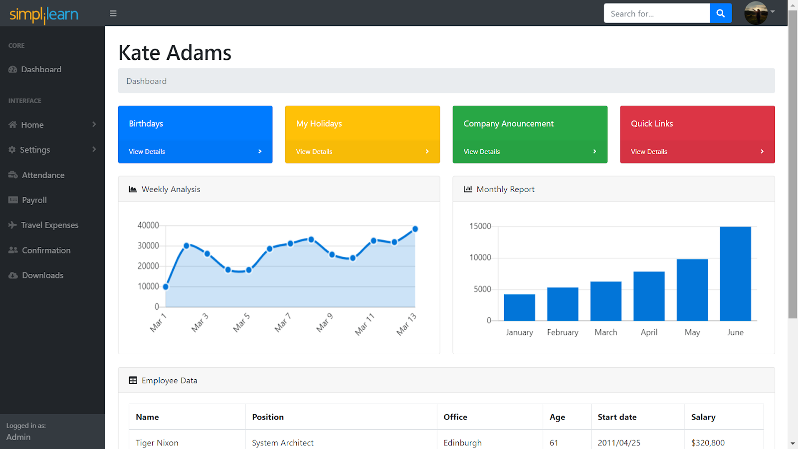

### **Step 6**

You can now add the routes for the required options. We have created five routes excluding the default route. As a result, we’ve created five components for the same.

For the Profile option under the Home option, we’ve created a component called toggle. The Html code for toggle.html is

<!DOCTYPE html>

<html lang="en">

    <head>

        <meta charset="utf-8" />

        <meta http-equiv="X-UA-Compatible" content="IE=edge" />

        <meta name="viewport" content="width=device-width, initial-scale=1, shrink-to-fit=no" />

        <meta name="description" content="" />

        <meta name="author" content="" />

        <title>Static Navigation - SB Admin</title>

         <!-- <link href="css/styles.css" rel="stylesheet" /> -->

        <script src="https://cdnjs.cloudflare.com/ajax/libs/font-awesome/5.15.1/js/all.min.js" crossorigin="anonymous"></script>

    </head>

    <body>

        <nav class="sb-topnav navbar navbar-expand navbar-dark bg-dark">

            <a class="navbar-brand" href="index.html"><img src="assets/Logo.png" width="80%" height="120%" style="padding-top: 10px;"></a>

            <button class="btn btn-link btn-sm order-1 order-lg-0" id="sidebarToggle" href="#"><i class="fas fa-bars"></i></button>

            <!-- Navbar Search-->

            <form class="d-none d-md-inline-block form-inline ml-auto mr-0 mr-md-3 my-2 my-md-0">

                <div class="input-group">

                    <input class="form-control" type="text" placeholder="Search for..." aria-label="Search" aria-describedby="basic-addon2" />

                    <div class="input-group-append">

                        <button class="btn btn-primary" type="button"><i class="fas fa-search"></i></button>

                    </div>

                </div>

            </form>

            <!-- Navbar-->

            <ul class="navbar-nav ml-auto ml-md-0">

                <li class="nav-item dropdown">

                    <a class="nav-link dropdown-toggle" id="userDropdown" href="#" role="button" data-toggle="dropdown" aria-haspopup="true" aria-expanded="false"><i class="fas fa-user fa-fw"></i></a>

                    <div class="dropdown-menu dropdown-menu-right" aria-labelledby="userDropdown">

                        <a class="dropdown-item" href="#">Settings</a>

                        <a class="dropdown-item" href="#">Activity Log</a>

                        <div class="dropdown-divider"></div>

                        <a class="dropdown-item" href="login.html">Logout</a>

                    </div>

                </li>

            </ul>

        </nav>

        <div id="layoutSidenav">

            <div id="layoutSidenav_nav">

                <nav class="sb-sidenav accordion sb-sidenav-dark" id="sidenavAccordion">

                    <div class="sb-sidenav-menu">

                        <div class="nav">

                            <div class="sb-sidenav-menu-heading">Core</div>

                            <a class="nav-link" href="index.html">

                                <div class="sb-nav-link-icon"><i class="fas fa-tachometer-alt"></i></div>

                                Dashboard

                            </a>

                            <div class="sb-sidenav-menu-heading">Interface</div>

                            <a class="nav-link collapsed" href="#" data-toggle="collapse" data-target="#collapseLayouts" aria-expanded="false" aria-controls="collapseLayouts">

                                <div class="sb-nav-link-icon"><i class="fas fa-columns"></i></div>

                                Home

                                <div class="sb-sidenav-collapse-arrow"><i class="fas fa-angle-down"></i></div>

                            </a>

                            <div class="collapse" id="collapseLayouts" aria-labelledby="headingOne" data-parent="#sidenavAccordion">

                                <nav class="sb-sidenav-menu-nested nav">

                                    <a class="nav-link" href="layout-static.html">Profile</a>

                                    <a class="nav-link" href="layout-sidenav-light.html">Settings</a>

                                </nav>

                            </div>

                            <a class="nav-link collapsed" href="#" data-toggle="collapse" data-target="#collapsePages" aria-expanded="false" aria-controls="collapsePages">

                                <div class="sb-nav-link-icon"><i class="fas fa-cog"></i></div>

                                Settings

                                <div class="sb-sidenav-collapse-arrow"><i class="fas fa-angle-down"></i></div>

                            </a>

                            <div class="collapse" id="collapsePages" aria-labelledby="headingTwo" data-parent="#sidenavAccordion">

                                <nav class="sb-sidenav-menu-nested nav accordion" id="sidenavAccordionPages">

                                    <a class="nav-link collapsed" href="#" data-toggle="collapse" data-target="#pagesCollapseAuth" aria-expanded="false" aria-controls="pagesCollapseAuth">

                                        Account Settings

                                        <div class="sb-sidenav-collapse-arrow"><i class="fas fa-angle-down"></i></div>

                                    </a>

                                    <div class="collapse" id="pagesCollapseAuth" aria-labelledby="headingOne" data-parent="#sidenavAccordionPages">

                                        <nav class="sb-sidenav-menu-nested nav">

                                            <a class="nav-link" href="#" routerLink = "/login" routerLinkActive = "active" >Login</a>

                                            <a class="nav-link" href="#" routerLink = "/register" routerLinkActive = "active" >Register</a>

                                            <a class="nav-link" href="#" routerLink = "/changepassword" routerLinkActive = "active">Change Password</a>

                                        </nav>

                                    </div>

                                    <a class="nav-link collapsed" href="#" data-toggle="collapse" data-target="#pagesCollapseError" aria-expanded="false" aria-controls="pagesCollapseError">

                                        Activity

                                        <div class="sb-sidenav-collapse-arrow"><i class="fas fa-angle-down"></i></div>

                                    </a>

                                    <div class="collapse" id="pagesCollapseError" aria-labelledby="headingOne" data-parent="#sidenavAccordionPages">

                                        <nav class="sb-sidenav-menu-nested nav">

                                            <a class="nav-link" href="401.html">401 Page</a>

                                            <a class="nav-link" href="404.html">404 Page</a>

                                            <a class="nav-link" href="500.html">500 Page</a>

                                        </nav>

                                    </div>

                                </nav>

                            <a class="nav-link collapsed" href="#">

                                <div class="sb-nav-link-icon"><i class="fas fa-business-time"></i></div>

                                Attendance

                            </a>

                            <a class="nav-link collapsed" href="#">

                                <div class="sb-nav-link-icon"><i class="fas fa-money-check-alt"></i></div>

                                Payroll

                            </a>

                            <a class="nav-link collapsed" href="#">

                                <div class="sb-nav-link-icon"><i class="fas fa-plane"></i></div>

                                Travel Expenses

                            </a>

                            <a class="nav-link collapsed" href="#">

                                <div class="sb-nav-link-icon"><i class="fas fa-user-friends"></i></div>

                                Confirmation

                            </a>

                            <a class="nav-link collapsed" href="#">

                                <div class="sb-nav-link-icon"><i class="fas fa-cloud-download-alt"></i></div>

                                Downloads

                            </a>

</div>

                    </div>

                    <div class="sb-sidenav-footer">

                        <div class="small">Logged in as:</div>

                        Admin

                    </div>

                </nav>

            </div>

            <div id="layoutSidenav_content">

                <main>

                    <div class="container-fluid">

                        <h1 class="mt-4">Kate's Personal Details</h1><br>

                        <ul class="breadcrumb mb-4">

                            <li class="breadcrumb-item"><img src="assets/id.jpg" width="140px" height="200px"></li>

                            <ul style="padding-top: 5px;"><li class="breadcrumb-item active">Name - Kate Adams</li> <br>

                            <li class="breadcrumb-item active">Employee ID - ap784</li> <br>

                            <li class="breadcrumb-item active">Date of Joining - 02/08/2018</li> <br>

                            <li class="breadcrumb-item active">Designation - Accountant</li> </ul> <br>

                        </ul>

</div>

                </main>

                <footer class="py-4 bg-light mt-auto">

                    <div class="container-fluid">

                        <div class="d-flex align-items-center justify-content-between small">

                            <div class="text-muted">Copyright &copy; Simplilearn 2021</div>

                            <div>

                                <a href="#">Privacy Policy</a>

                                &middot;

                                <a href="#">Terms &amp; Conditions</a>

                            </div>

                        </div>

                    </div>

                </footer>

            </div>

        </div>

        <script src="https://code.jquery.com/jquery-3.5.1.slim.min.js" crossorigin="anonymous"></script>

        <script src="https://cdn.jsdelivr.net/npm/bootstrap@4.5.3/dist/js/bootstrap.bundle.min.js" crossorigin="anonymous"></script>

        <script src="js/scripts.js"></script>

    </body>

We’ve also added the relevant path to the route in the app-routing.module.ts

{path: 'static',component: ToggleComponent, pathMatch: 'full'},

The path id we have given is static. Once run, the application looks like this.



### **Step 7**

Add the routes for the login, register, and change password options in Settings>>Account settings option.

The code for Login-component.html is

<!DOCTYPE html>

<html lang="en">

    <head>

        <meta charset="utf-8" />

        <meta http-equiv="X-UA-Compatible" content="IE=edge" />

        <meta name="viewport" content="width=device-width, initial-scale=1, shrink-to-fit=no" />

        <meta name="description" content="" />

        <meta name="author" content="" />

        <title>Page Title - SB Admin</title>

        <script src="https://cdnjs.cloudflare.com/ajax/libs/font-awesome/5.15.1/js/all.min.js" crossorigin="anonymous"></script>

    </head>

    <body class="bg-primary">

        <div id="layoutAuthentication">

            <div id="layoutAuthentication_content">

                <main>

                    <div class="container">

                        <div class="row justify-content-center">

                            <div class="col-lg-5">

                                <div class="card shadow-lg border-0 rounded-lg mt-5">

                                    <div class="card-header"><h3 class="text-center font-weight-light my-4">Login</h3></div>

                                    <div class="card-body">

                                        <form>

                                            <div class="form-group">

                                                <label class="small mb-1" for="inputEmailAddress">Email</label>

                                                <input class="form-control py-4" id="inputEmailAddress" type="email" placeholder="Enter email address" />

                                            </div>

                                            <div class="form-group">

                                                <label class="small mb-1" for="inputPassword">Password</label>

                                                <input class="form-control py-4" id="inputPassword" type="password" placeholder="Enter password" />

                                            </div>

                                            <div class="form-group">

                                                <div class="custom-control custom-checkbox">

                                                    <input class="custom-control-input" id="rememberPasswordCheck" type="checkbox" />

                                                    <label class="custom-control-label" for="rememberPasswordCheck">Remember password</label>

                                                </div>

                                            </div>

                                            <div class="form-group d-flex align-items-center justify-content-between mt-4 mb-0">

                                                <a class="small" href="password.html">Forgot Password?</a>

                                                <a class="btn btn-primary" href="index.html">Login</a>

                                            </div>

                                        </form>

                                    </div>

                                    <div class="card-footer text-center">

                                        <div class="small"><a href="register.html">Need an account? Sign up!</a></div>

                                    </div>

                                </div>

                            </div>

                        </div>

                    </div>

                </main>

            </div>

            <div id="layoutAuthentication_footer">

                <footer class="py-4 bg-light mt-auto">

                    <div class="container-fluid">

                        <div class="d-flex align-items-center justify-content-between small">

                            <div class="text-muted">Copyright &copy; Simplilearn 2021</div>

                            <div>

                                <a href="#">Privacy Policy</a>

                                &middot;

                                <a href="#">Terms &amp; Conditions</a>

                            </div>

                        </div>

                    </div>

                </footer>

            </div>

        </div>

        <script src="https://code.jquery.com/jquery-3.5.1.slim.min.js" crossorigin="anonymous"></script>

        <script src="https://cdn.jsdelivr.net/npm/bootstrap@4.5.3/dist/js/bootstrap.bundle.min.js" crossorigin="anonymous"></script>

        <script src="js/scripts.js"></script>

    </body>

</html>

Add the route in the app-routing.module.ts file

{path:'login',component: LoginComponent},

The output looks like this:



Create another component for registration and add the code in the register.html file

<html lang="en">

    <head>

        <meta charset="utf-8" />

        <meta http-equiv="X-UA-Compatible" content="IE=edge" />

        <meta name="viewport" content="width=device-width, initial-scale=1, shrink-to-fit=no" />

        <meta name="description" content="" />

        <meta name="author" content="" />

        <title>Page Title - SB Admin</title>

        <!-- <link href="css/styles.css" rel="stylesheet" /> -->

        <script src="https://cdnjs.cloudflare.com/ajax/libs/font-awesome/5.15.1/js/all.min.js" crossorigin="anonymous"></script>

    </head>

    <body class="bg-primary">

        <div id="layoutAuthentication">

            <div id="layoutAuthentication_content">

                <main>

                    <div class="container">

                        <div class="row justify-content-center">

                            <div class="col-lg-7">

                                <div class="card shadow-lg border-0 rounded-lg mt-5">

                                    <div class="card-header"><h3 class="text-center font-weight-light my-4">Create Account</h3></div>

                                    <div class="card-body">

                                        <form>

                                            <div class="form-row">

                                                <div class="col-md-6">

                                                    <div class="form-group">

                                                        <label class="small mb-1" for="inputFirstName">First Name</label>

                                                        <input class="form-control py-4" id="inputFirstName" type="text" placeholder="Enter first name" />

                                                    </div>

                                                </div>

                                                <div class="col-md-6">

                                                    <div class="form-group">

                                                        <label class="small mb-1" for="inputLastName">Last Name</label>

                                                        <input class="form-control py-4" id="inputLastName" type="text" placeholder="Enter last name" />

                                                    </div>

                                                </div>

                                            </div>

                                            <div class="form-group">

                                                <label class="small mb-1" for="inputEmailAddress">Email</label>

                                                <input class="form-control py-4" id="inputEmailAddress" type="email" aria-describedby="emailHelp" placeholder="Enter email address" />

                                            </div>

                                            <div class="form-row">

                                                <div class="col-md-6">

                                                    <div class="form-group">

                                                        <label class="small mb-1" for="inputPassword">Password</label>

                                                        <input class="form-control py-4" id="inputPassword" type="password" placeholder="Enter password" />

                                                    </div>

                                                </div>

                                                <div class="col-md-6">

                                                    <div class="form-group">

                                                        <label class="small mb-1" for="inputConfirmPassword">Confirm Password</label>

                                                        <input class="form-control py-4" id="inputConfirmPassword" type="password" placeholder="Confirm password" />

                                                    </div>

                                                </div>

                                            </div>

                                            <div class="form-group mt-4 mb-0"><a class="btn btn-primary btn-block" href="login.html">Create Account</a></div>

                                        </form>

                                    </div>

                                    <div class="card-footer text-center">

                                        <div class="small"><a href="login.html">Have an account? Go to login</a></div>

                                    </div>

                                </div>

                            </div>

                        </div>

                    </div>

                </main>

            </div>

            <div id="layoutAuthentication_footer">

                <footer class="py-4 bg-light mt-auto">

                    <div class="container-fluid">

                        <div class="d-flex align-items-center justify-content-between small">

                            <div class="text-muted">Copyright &copy; Simplilearn 2021</div>

                            <div>

                                <a href="#">Privacy Policy</a>

                                &middot;

                                <a href="#">Terms &amp; Conditions</a>

                            </div>

                        </div>

                    </div>

                </footer>

            </div>

        </div>

        <script src="https://code.jquery.com/jquery-3.5.1.slim.min.js" crossorigin="anonymous"></script>

        <script src="https://cdn.jsdelivr.net/npm/bootstrap@4.5.3/dist/js/bootstrap.bundle.min.js" crossorigin="anonymous"></script>

        <script src="js/scripts.js"></script>

    </body>

</html>

Add the routing path in the app-routing.module.ts file

{path: 'register', component: RegisterComponent},

The output will look something like this:



Create another component to display the content for the forgot password option. The HTML code is given below.

<html lang="en">

    <head>

        <meta charset="utf-8" />

        <meta http-equiv="X-UA-Compatible" content="IE=edge" />

        <meta name="viewport" content="width=device-width, initial-scale=1, shrink-to-fit=no" />

        <meta name="description" content="" />

        <meta name="author" content="" />

        <title>Page Title - SB Admin</title>

        <!-- <link href="css/styles.css" rel="stylesheet" /> -->

        <script src="https://cdnjs.cloudflare.com/ajax/libs/font-awesome/5.15.1/js/all.min.js" crossorigin="anonymous"></script>

    </head>

    <body class="bg-primary">

        <div id="layoutAuthentication">

            <div id="layoutAuthentication_content">

                <main>

                    <div class="container">

                        <div class="row justify-content-center">

                            <div class="col-lg-5">

                                <div class="card shadow-lg border-0 rounded-lg mt-5">

                                    <div class="card-header"><h3 class="text-center font-weight-light my-4">Change Password</h3></div>

                                    <div class="card-body">

                                        <div class="small mb-3 text-muted">Enter your email address and we will send you a link to reset your password.</div>

                                        <form>

                                            <div class="form-group">

                                                <label class="small mb-1" for="inputEmailAddress">Email</label>

                                                <input class="form-control py-4" id="inputEmailAddress" type="email" aria-describedby="emailHelp" placeholder="Enter email address" />

                                            </div>

                                            <div class="form-group d-flex align-items-center justify-content-between mt-4 mb-0">

                                                <a class="small" href="login.html">Return to login</a>

                                                <a class="btn btn-primary" href="login.html">Reset Password</a>

                                            </div>

                                        </form>

                                    </div>

                                    <div class="card-footer text-center">

                                        <div class="small"><a href="register.html">Need an account? Sign up!</a></div>

                                    </div>

                                </div>

                            </div>

                        </div>

                    </div>

                </main>

            </div>

            <div id="layoutAuthentication_footer">

                <footer class="py-4 bg-light mt-auto">

                    <div class="container-fluid">

                        <div class="d-flex align-items-center justify-content-between small">

                            <div class="text-muted">Copyright &copy; Simplilearn 2021</div>

                            <div>

                                <a href="#">Privacy Policy</a>

                                &middot;

                                <a href="#">Terms &amp; Conditions</a>

                            </div>

                        </div>

                    </div>

                </footer>

            </div>

        </div>

        <script src="https://code.jquery.com/jquery-3.5.1.slim.min.js" crossorigin="anonymous"></script>

        <script src="https://cdn.jsdelivr.net/npm/bootstrap@4.5.3/dist/js/bootstrap.bundle.min.js" crossorigin="anonymous"></script>

        <script src="js/scripts.js"></script>

    </body>

</html>

Add the route in the app-routing.module.ts file.

{path: 'changepassword', component: PasswordComponent}

The output looks like this:

[[ROuting_password GIF]]

Step 8: Add a default route for the navbar in the app-routing.module.ts file.

import { NgModule } from '@angular/core';

import { Routes, RouterModule } from '@angular/router';

import { NavbarComponent } from './navbar/navbar.component';

import { LoginComponent } from './Routes/login/login.component';

import { PasswordComponent } from './Routes/password/password.component';

import { RegisterComponent } from './Routes/register/register.component';

import { ToggleComponent } from './toggle/toggle.component';

const routes: Routes = [

  {path: '',component: NavbarComponent},

  {path: 'static',component: ToggleComponent, pathMatch: 'full'},

  {path:'login',component: LoginComponent},

  {path: 'register', component: RegisterComponent},

  {path: 'changepassword', component: PasswordComponent},

];

@NgModule({

  imports: [RouterModule.forRoot(routes)],

  exports: [RouterModule]

})

export class AppRoutingModule { }